QuantityWare Calculation Issue Questionnaire

Support Analysis of QCI Configuration Settings

QuantityWare Calculation Issue Questionnaire
Contents
Introduction 3
Part 1 - O3QCITEST Calculation Data 5
Part 2 - Conversion Group Configuration 7
Part 3 - Reading Group Configuration 15
Summary 18

Introduction
- This questionnaire is an integral part of the QuantityWare Customer Remote Support Manual.
- Fill out this questionnaire with all details required for the analysis of your quantity conversion issue within your SAP Oil & Gas system.
- Provide screen prints requested in this questionnaire via the Petroleum or Gas Measurement Cockpits (PMC / GMC) and customizing transactions accessible via the PMC or GMC - transactions /n/qtyw/cockpit and /n/qtyw/cockpit_gas.
- Do NOT utilize legacy SAP IMG QCI configuration transactions to provide the screen prints.
- Perform the test conversion calculation via transaction O3QCITEST (accessible from the QuantityWare Petroleum or Gas Measurement Cockpit) in your development or quality assurance system where the issue occurs – use the conversion group for the test calculation, NOT the material/plant data. The conversion group is assigned to a material at plant level and can be displayed in the Oil-specific data view in the material master.
Example:
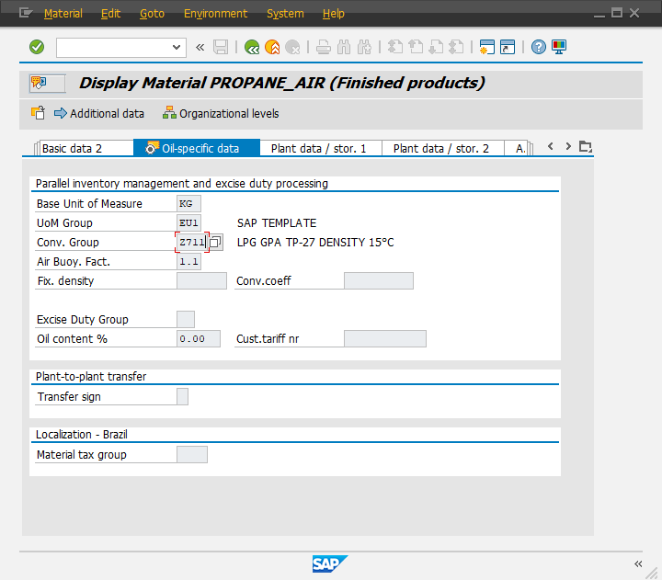

The SAP QCI and MQCI conversion groups perform all calculations via one central SAP function module: OIB_QCI_QUANTITY_CONTROL.
Thus, any issues or calculation errors must be demonstrated via the central SAP QCI test transaction (O3QCITEST).
If an issue cannot be demonstrated via this central test transaction, the cause of the issue must be within the calling SAP application (e.g. TD shipment, TSW ticketing, Delivery processing, Goods Movement postings, PRA Measurement System) or related configuration to these applications (e.g. QCI parameter defaulting, UoM defaulting) and QuantityWare cannot provide support for such issues.

Part 1 - O3QCITEST Calculation Data
- Launch the Petroleum or Gas Measurement System and start the Oil & Gas Test Calculator:
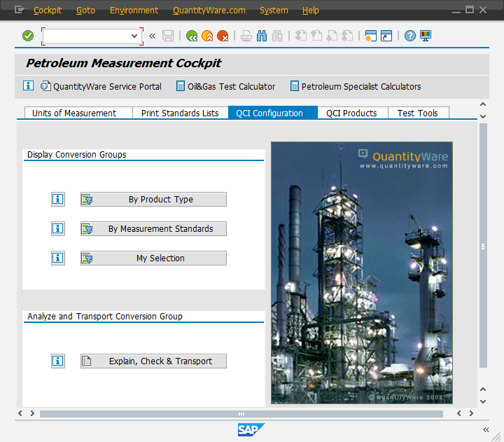
Example: You wish to report an issue for conversion group Z711:
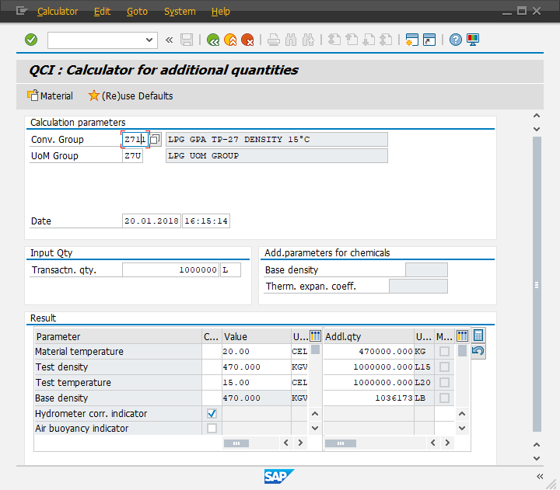

- Describe the Issue with a few precise sentences:
Click or tap here to enter text.

- Provide a screen print of the test calculation as shown on the previous page, such that the conversion group (and UoM group) is used for calculation:
Example: The quantity values for L15 and L20 are identical for all test calculations for conversion group Z711 and do not depend on the material temperature.

Part 2 - Conversion Group Configuration
- Via the PMC, navigate to menu path: Goto Conversion Groups:
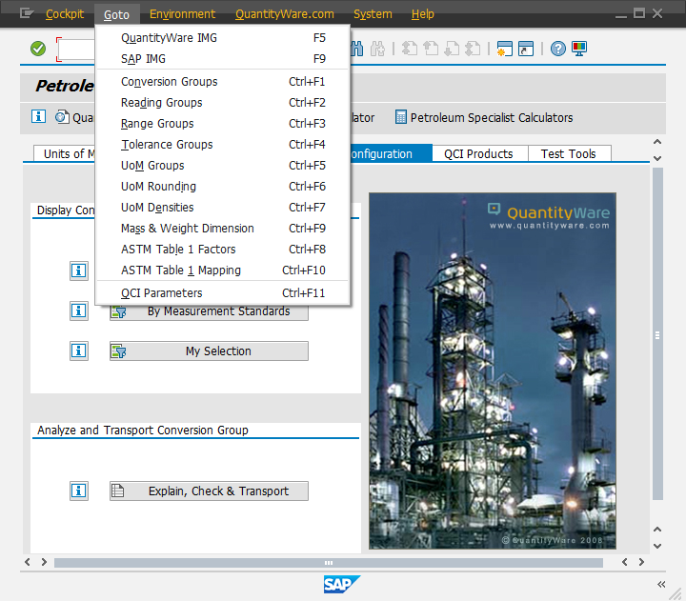

- Provide a screen print of the affected conversion group – Overview
Example:
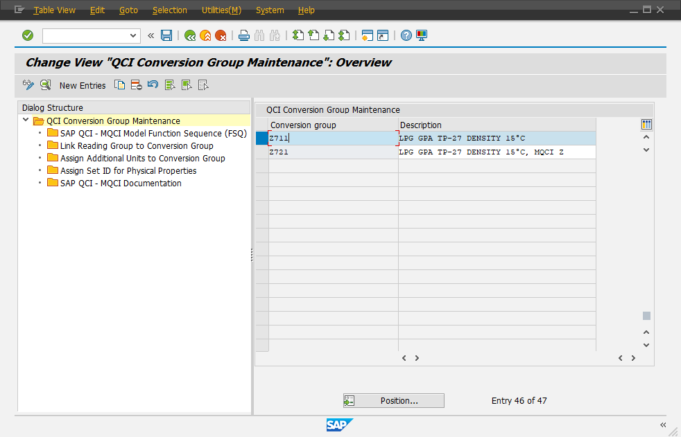
Provide your screen print:

- Double click on your affected conversion group
- Provide a screen print of the conversion group configuration settings (you might need to add two screen prints if the settings do not fit into a single screen)
Example:
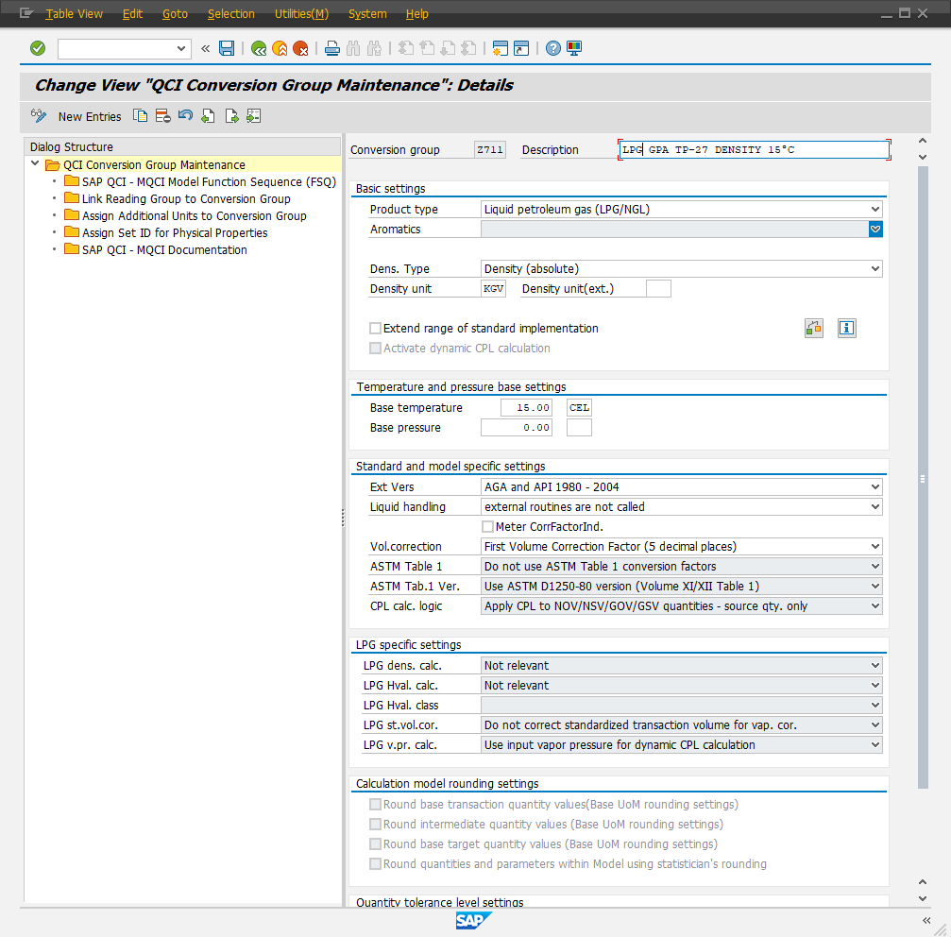
Provide your screen prints:

- Provide a screen print of the SAP QCI - MQCI Model Function Sequence
Example:
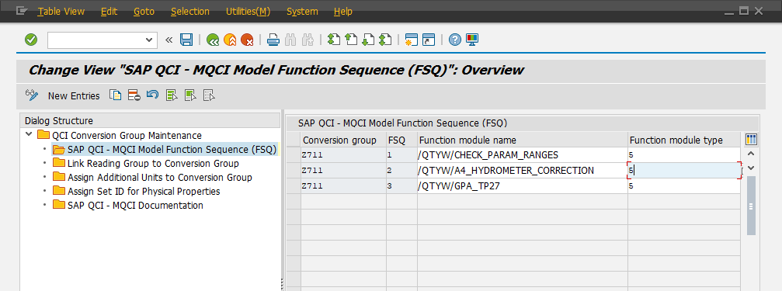
Provide your screen print:

- Provide a screen print of "Link Reading Group to Conversion Group"
Example:
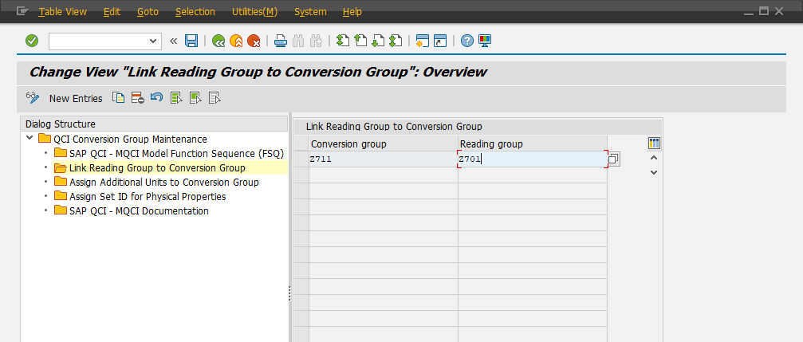
Provide your screen print:

- Provide a screen print of " Assign Additional Units to Conversion Group"
Example:
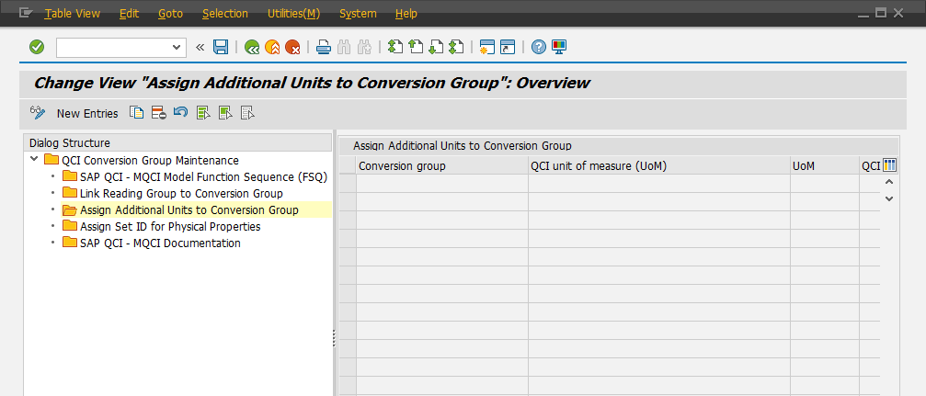
Provide your screen print:

- Provide a screen print of "Assign Set ID for Physical Properties"
Example:
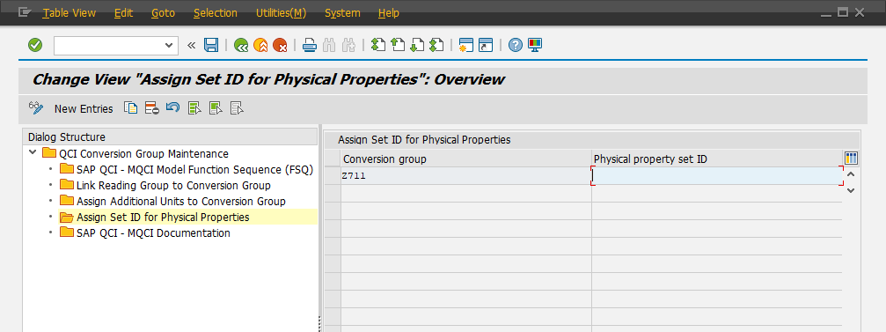
Provide your screen print:

- Provide a screen print of " SAP QCI - MQCI Documentation "
Example:
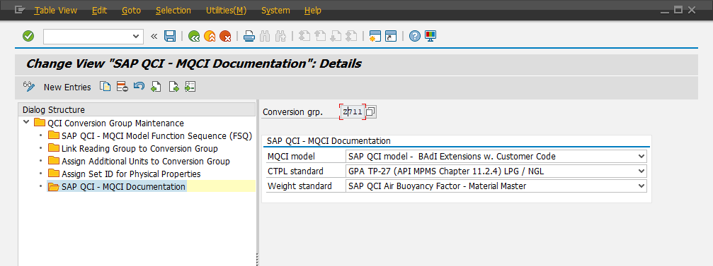
Provide your screen print:

Part 3 - Reading Group Configuration
- Via the PMC, navigate to menu path: Goto Reading Groups:

- Provide a screen print of the affected reading group – Overview
Example:
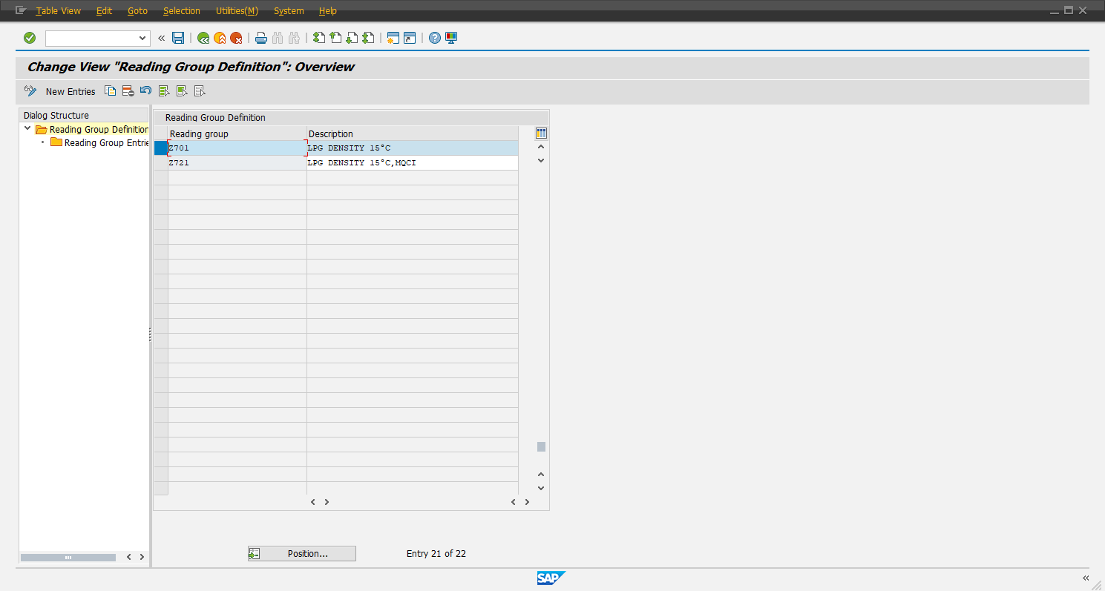

Provide your screen print:

- Provide a screen print of all reading group entries
Example:
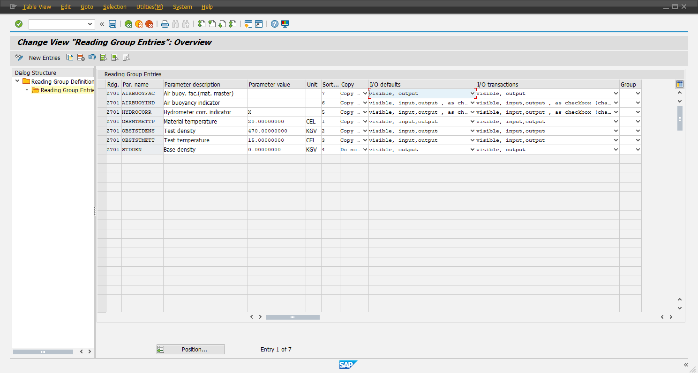
Provide your screen print:

Summary
Please provide all screen prints as described above.
If screen prints are missing, QuantityWare Support staff may send back your ticket requesting completion before an analysis can be started.
The Example in this questionnaire is a realistic example, where QuantityWare support can identify the configuration error that leads to the calculation error.
However, since the conversion group configuration (e.g. for LNG, NGL/LPG and Natural Gas or dedicated rounding requirements) depends on many more configuration tables, QuantityWare Support may ask you to provide additional screen prints before the analysis can start.

