QuantityWare

Calculation Issue Questionnaire
Support Analysis of QCI Configuration Settings
Contents
Introduction 3
Part 1 – O3QCITEST Calculation Data 6
1. Part 2 - Conversion Group Configuration 8
2. Part 3 - Reading Group Configuration 17
3. Summary 20

Note
The latest version of this documentation can be found in the QuantityWare Knowledge Base.
All documentation is kept current for the combinations of latest BCS release with the latest supported SAP Oil, Gas, & Energy release.
For all currently supported combinations see Note #000086 “Support and Release (Lifecycle) details” page 2, “Release Lifecycle”.
Your release level can be determined via:
“/o/QTYW/COCKPIT” -> “Cockpit” -> “Support Package Level” or
“/o/QTYW/COCKPIT_GAS” -> “Cockpit” -> “Support Package Level”

Introduction
- This questionnaire is an integral part of the QuantityWare Remote Support Manual.
- Fill out this questionnaire with all details required for the analysis of your quantity conversion issue within your SAP Oil, Gas, & Energy system.
- Provide screen prints requested in this questionnaire via the Petroleum or Gas Measurement Cockpits (PMC / GMC) and QuantityWare customizing transactions accessible via the PMC or GMC - transactions /n/qtyw/cockpit and /n/qtyw/cockpit_gas or the QuantityWare IMG that is integrated into the SAP IMG:
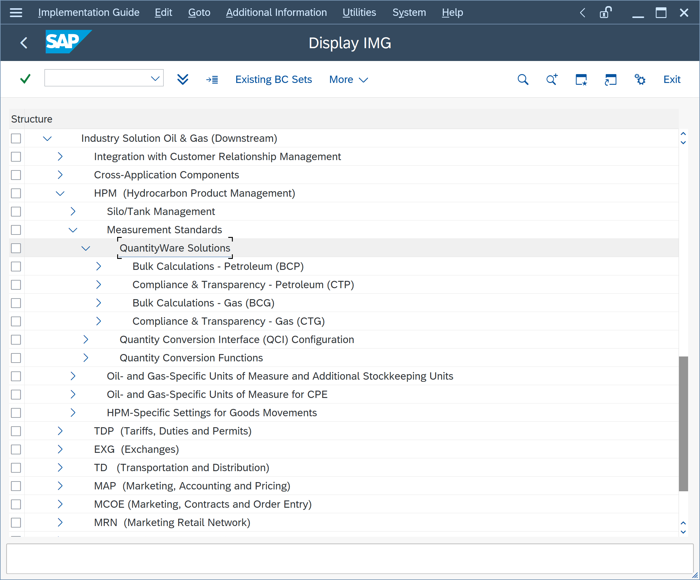
- Do NOT utilize legacy SAP IMG QCI configuration transactions to provide the screen prints.
- Perform the test conversion calculation(s) via transaction O3QCITEST (accessible from the QuantityWare Petroleum or Gas Measurement Cockpit) in your development or quality assurance system where the issue occurs.
- Use the conversion group for the test calculation, not the material/plant data. The conversion group is assigned to a material at plant level and can be displayed in the Oil-specific data view in the material master.
Example:
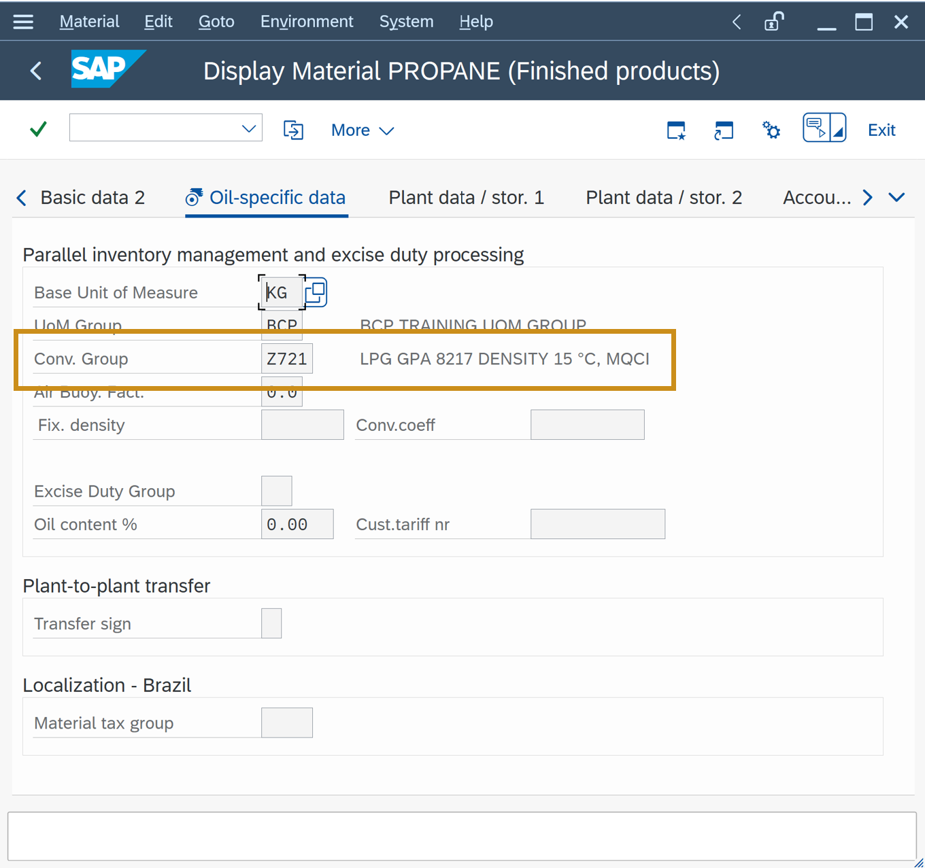
The SAP QCI and MQCI conversion groups perform all quantity conversion calculations via one central SAP function module:
OIB_QCI_QUANTITY_CONTROL
There exists no SAP Oil, Gas, & Energy application specific quantity conversion program code within the QCI calculation logic. Thus, any calculation issues or related error messages must be demonstrated via the central SAP QCI test transaction O3QCITEST.
If a calculation issue cannot be demonstrated via this central test transaction, the cause of the issue must be within the “calling” SAP application (e.g., TD shipment, TSW ticketing, Delivery processing, Goods Movement postings, PRA Measurement System) or their related application configuration (e.g., QCI parameter defaulting, UoM defaulting).
QuantityWare BCS is a non-modifying solution. All BCS ABAP programs are defined within the name space /QTYW/. Thus, no program corrections can be made within SAP Oil, Gas, & Energy programs if an SAP Oil, Gas, & Energy program is causing the issue. Then, QuantityWare support will ask you to contact SAP support.
For certain issues, that can be solved via configuration within SAP Oil, Gas, & Energy applications, QuantityWare support may refer you to already existing or newly created FAQs .

Part 1 – O3QCITEST Calculation Data
- Launch the Petroleum or Gas Measurement System and start the Oil & Gas Test Calculator:
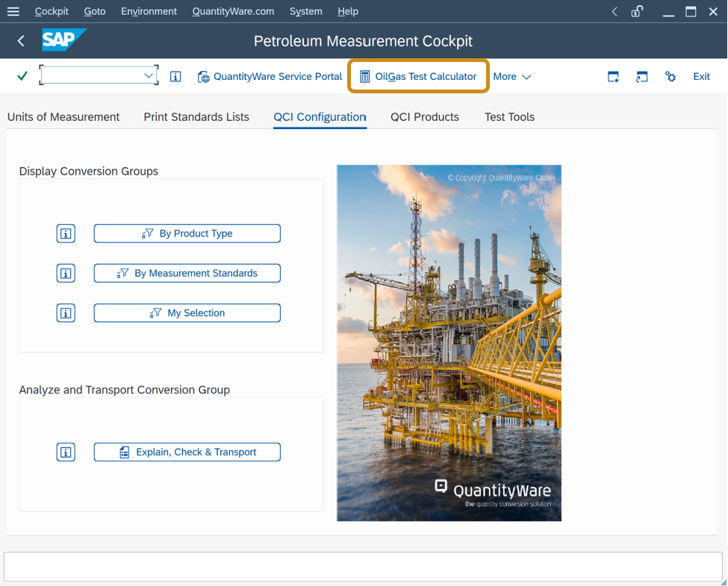
- Example: You wish to report an issue for conversion group Z711:
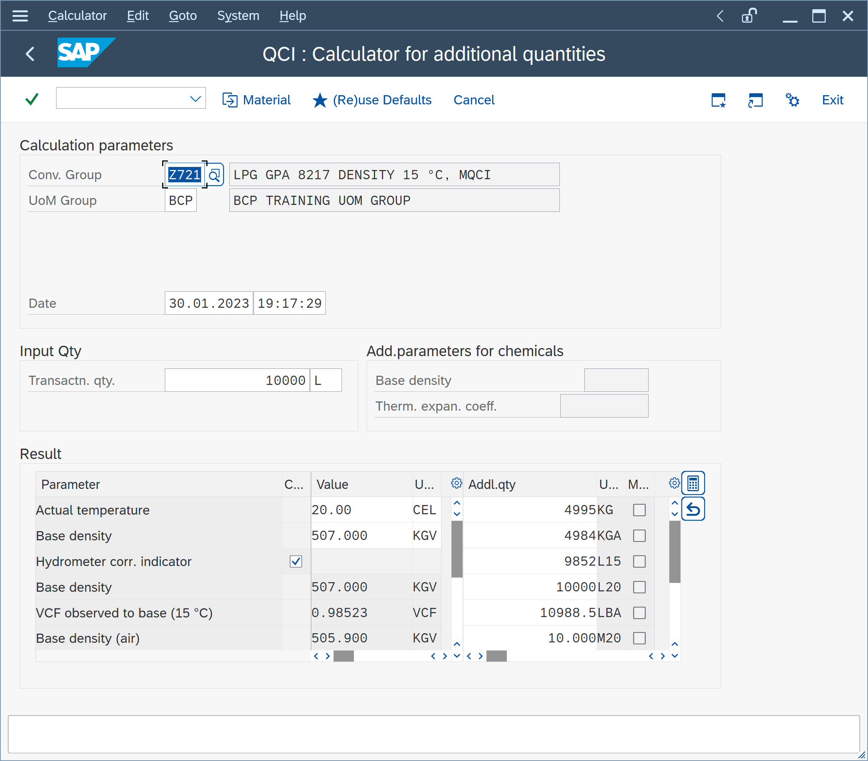

- Describe the Issue with a few precise sentences:
Click or tap here to enter text.
- Provide a screen print of the test calculation as shown on the previous page, such that the conversion group (and UoM group) is used for calculation:

Part 2 - Conversion Group Configuration
- Via the PMC, navigate to menu path: Goto Conversion Groups:
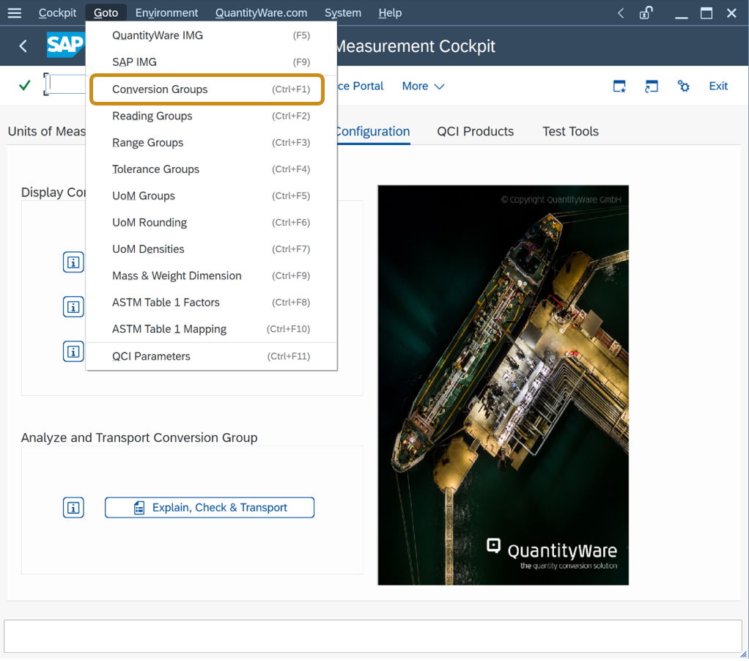
- Provide a screen print of the affected conversion group – Overview
Example:
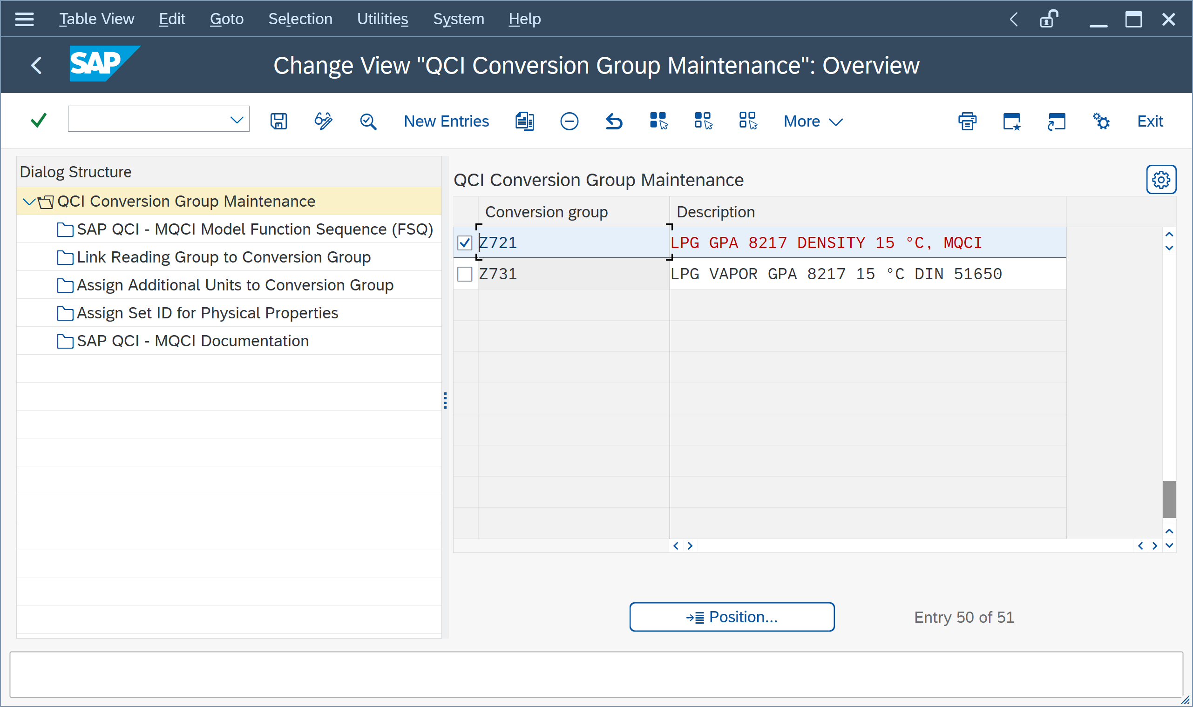
Provide your screen print:

- Double click on your affected conversion group
- Provide a screen print of the conversion group configuration settings (you might need to add two screen prints if the settings do not fit into a single screen)
Example:
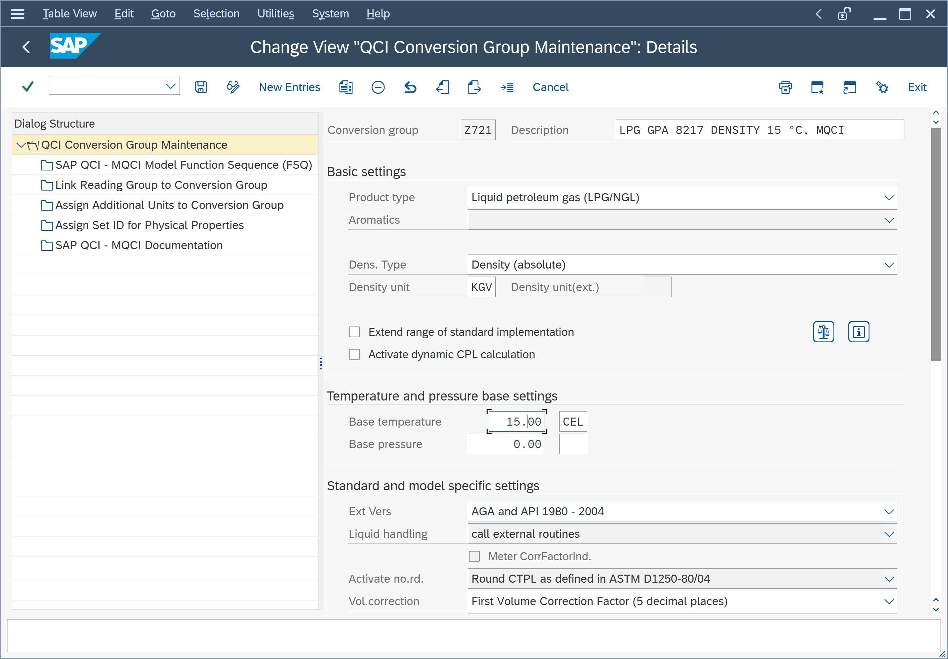
Provide your screen prints:

- Execute the conversion group configuration check:
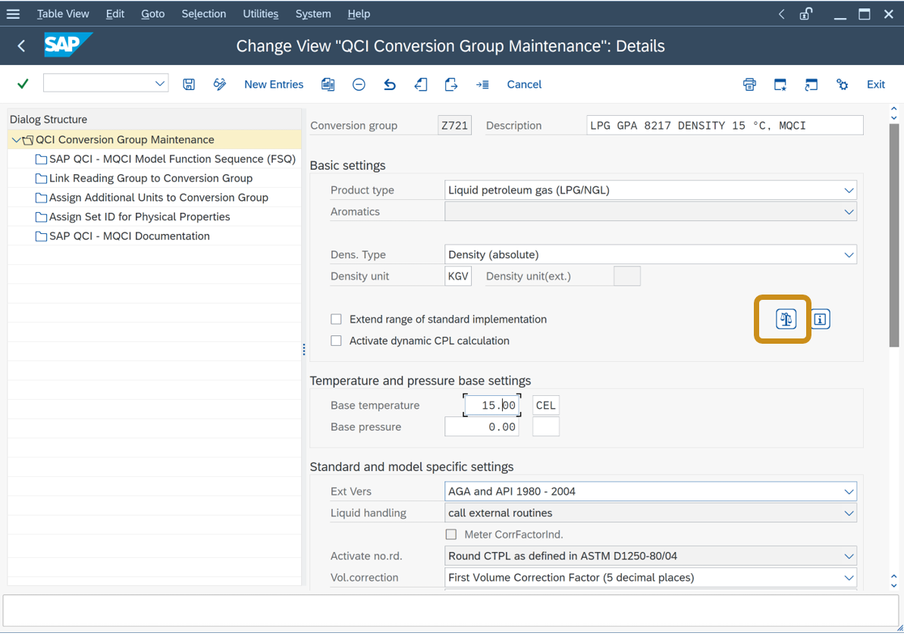
- And provide the result:
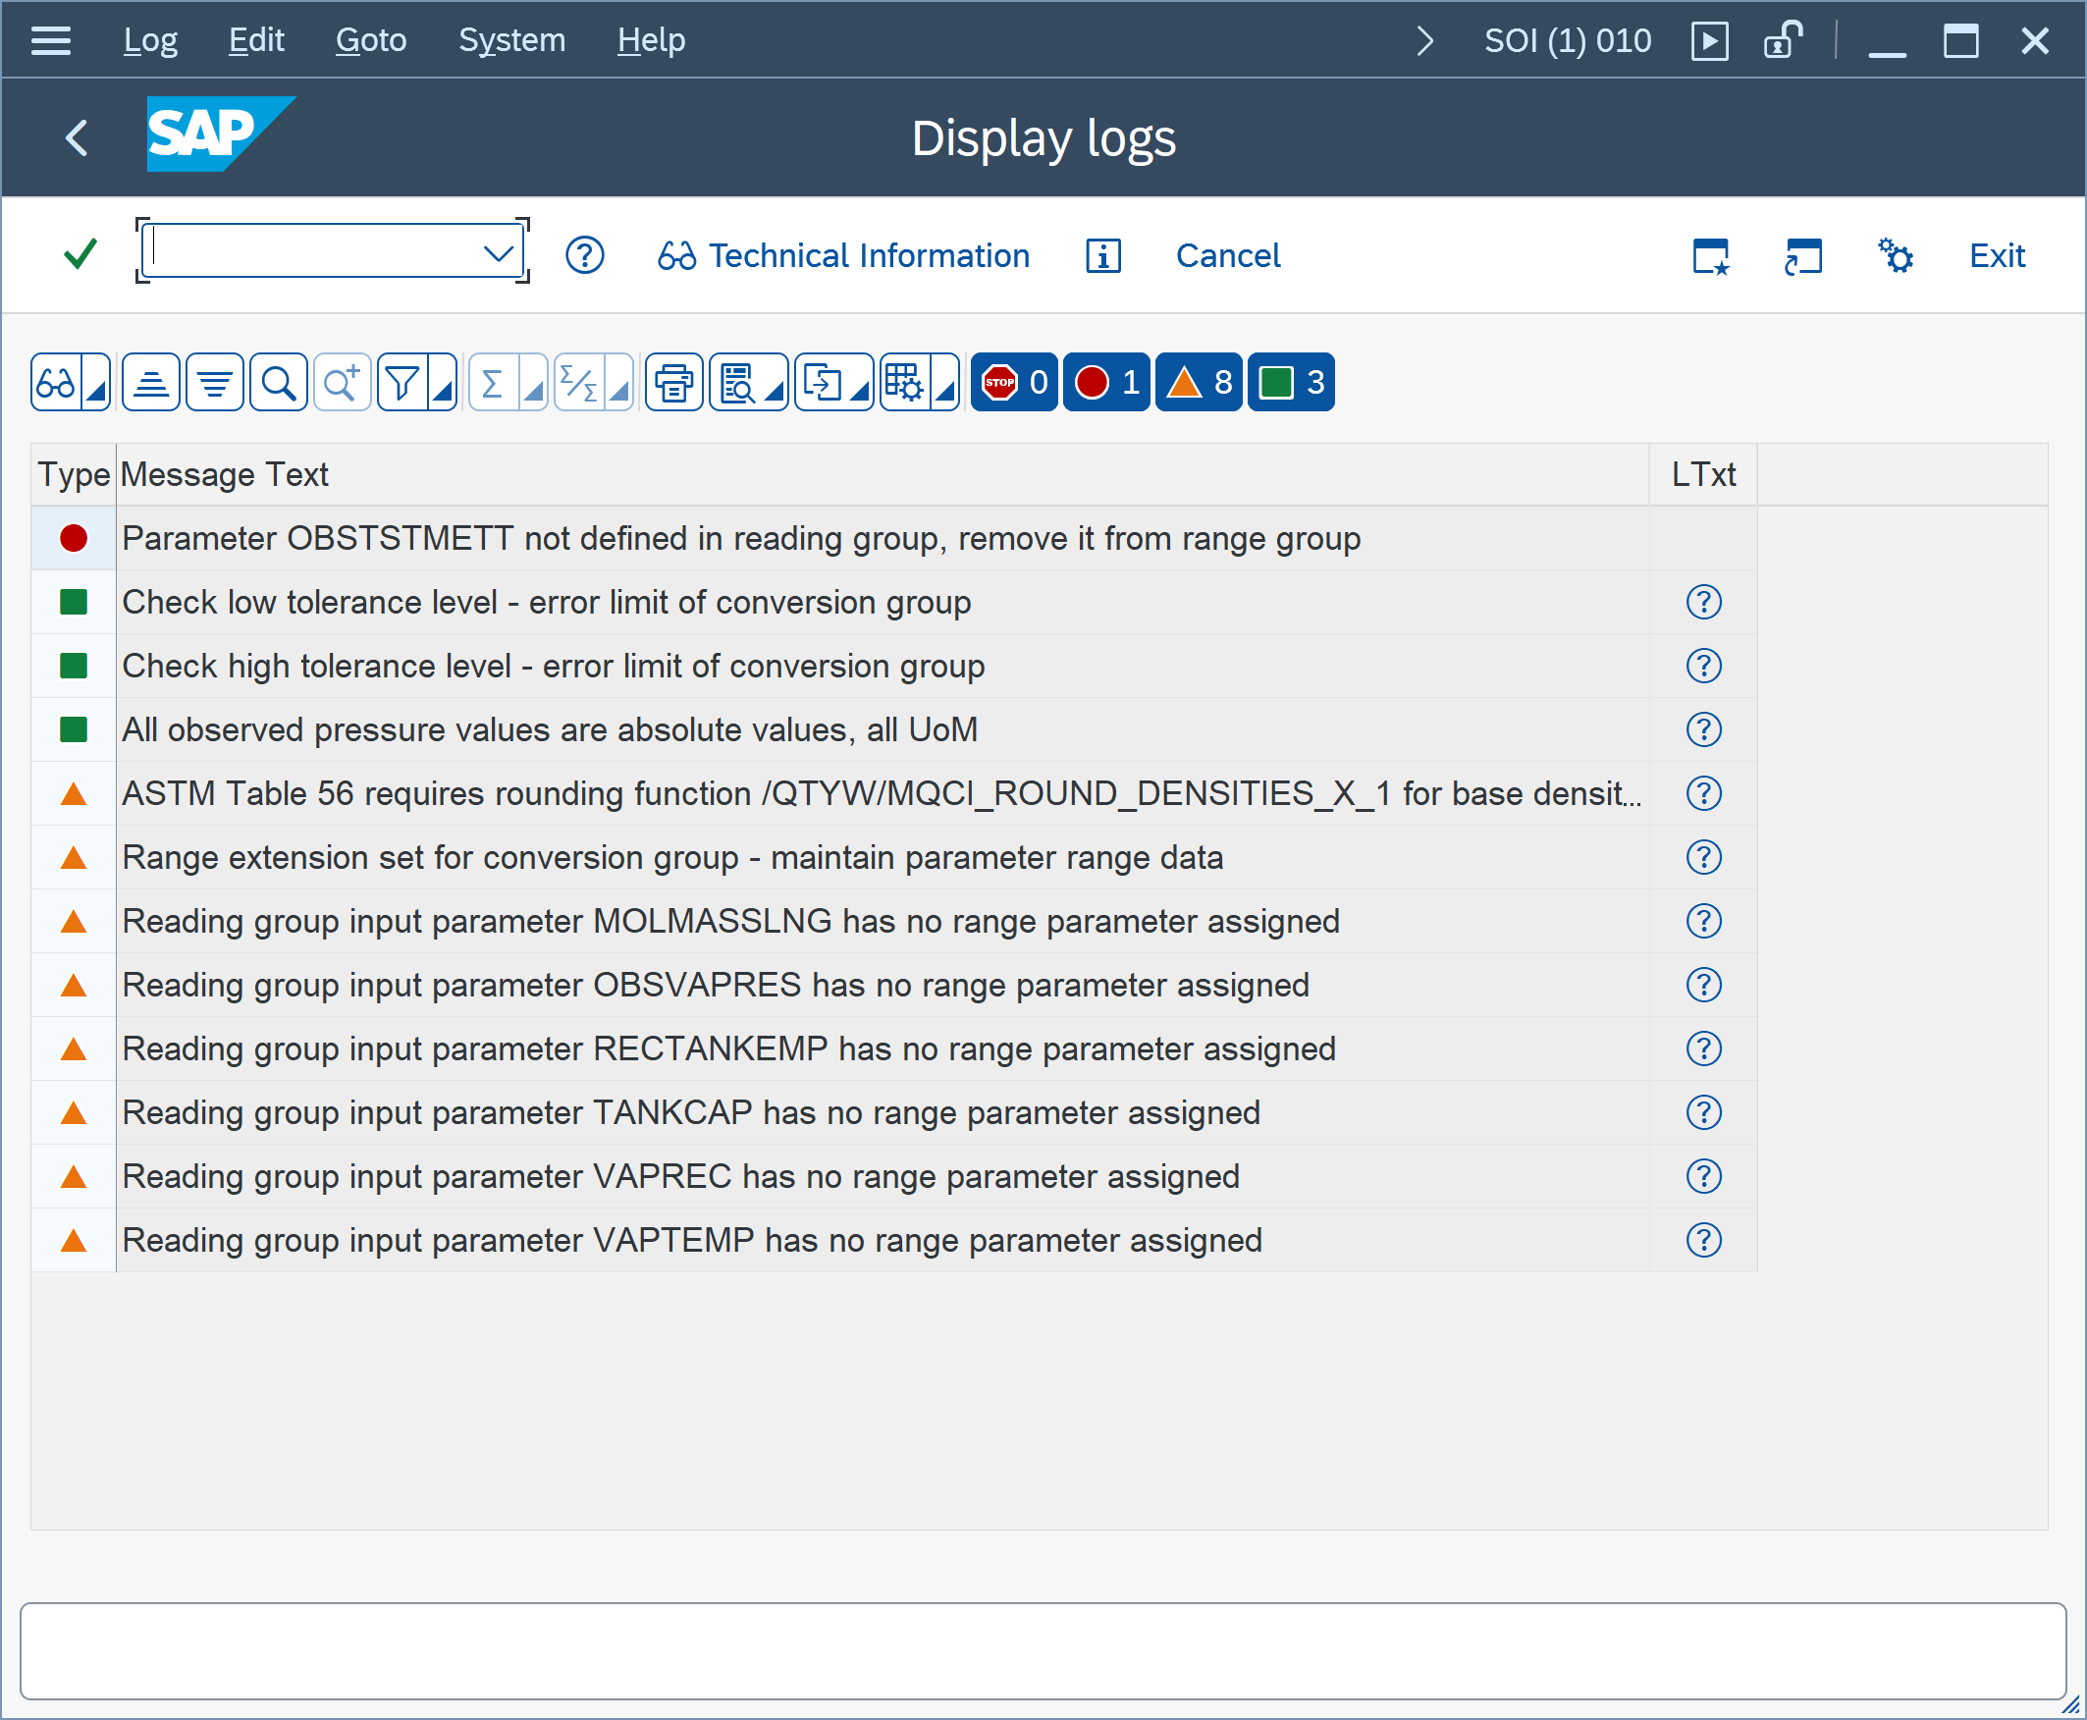

- Provide a screen print of the SAP QCI - MQCI Model Function Sequence
Example:
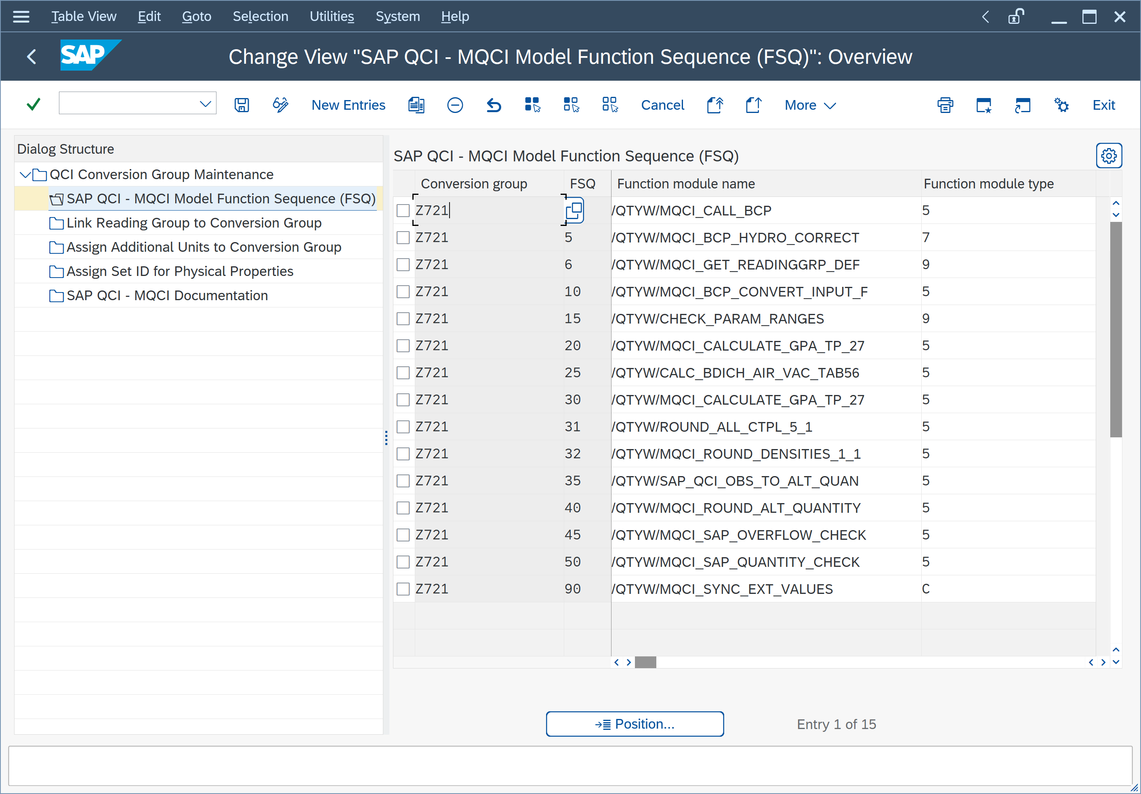
Provide your screen print:

- Provide a screen print of "Link Reading Group to Conversion Group"
Example:
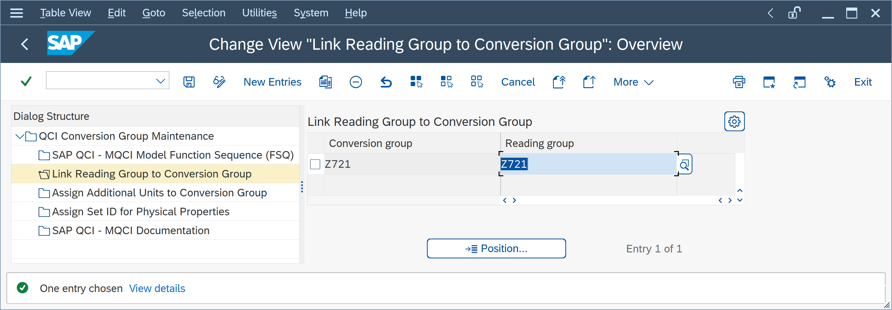
Provide your screen print:

- Provide a screen print of " Assign Additional Units to Conversion Group"
Example:
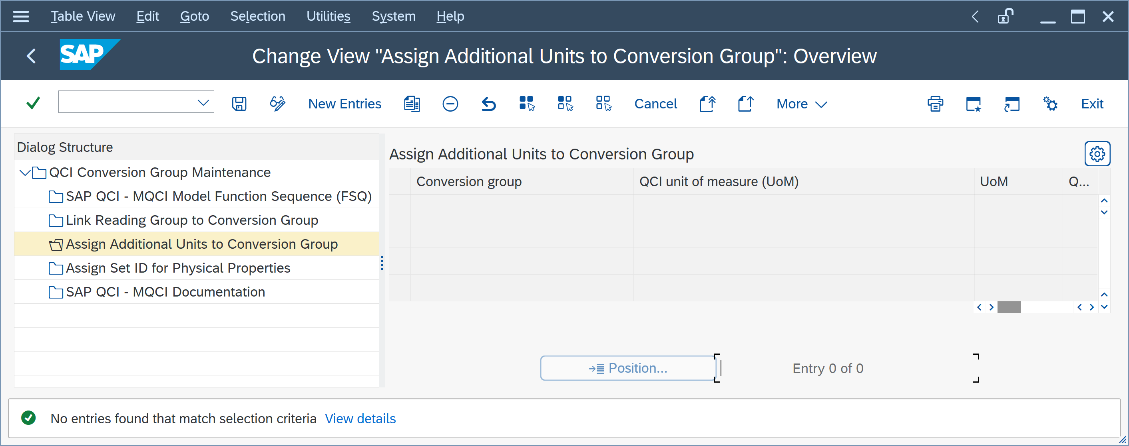
Provide your screen print:

- Provide a screen print of "Assign Set ID for Physical Properties"
Example:
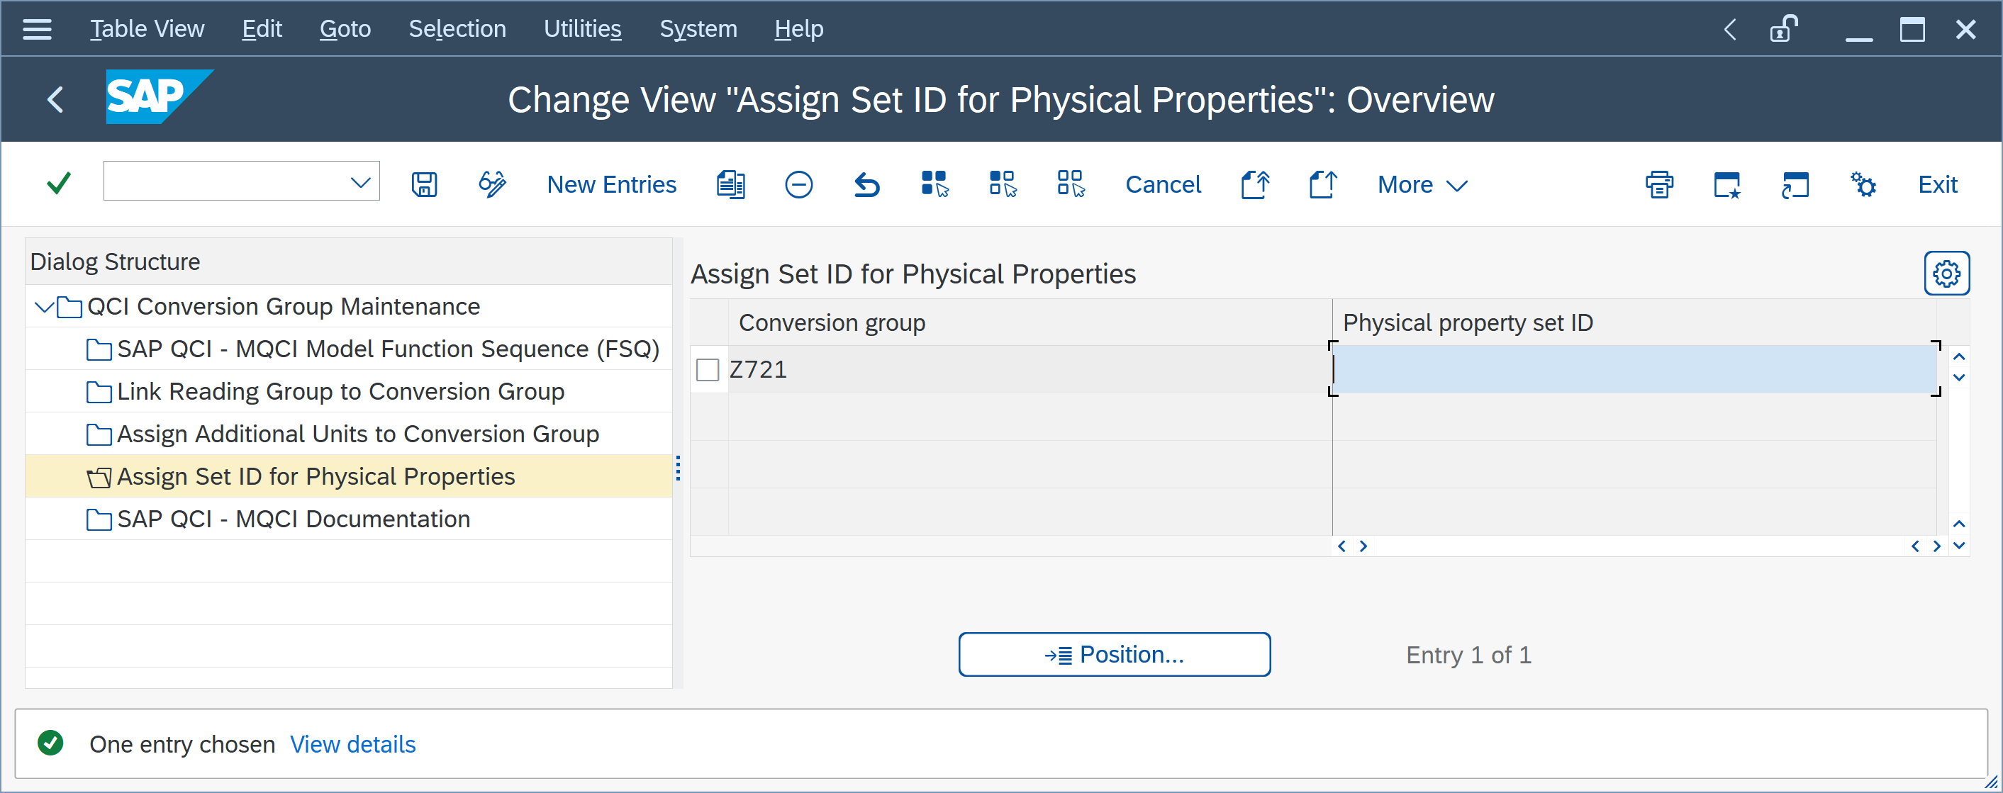
Provide your screen print:

- Provide a screen print of " SAP QCI - MQCI Documentation "
Example:
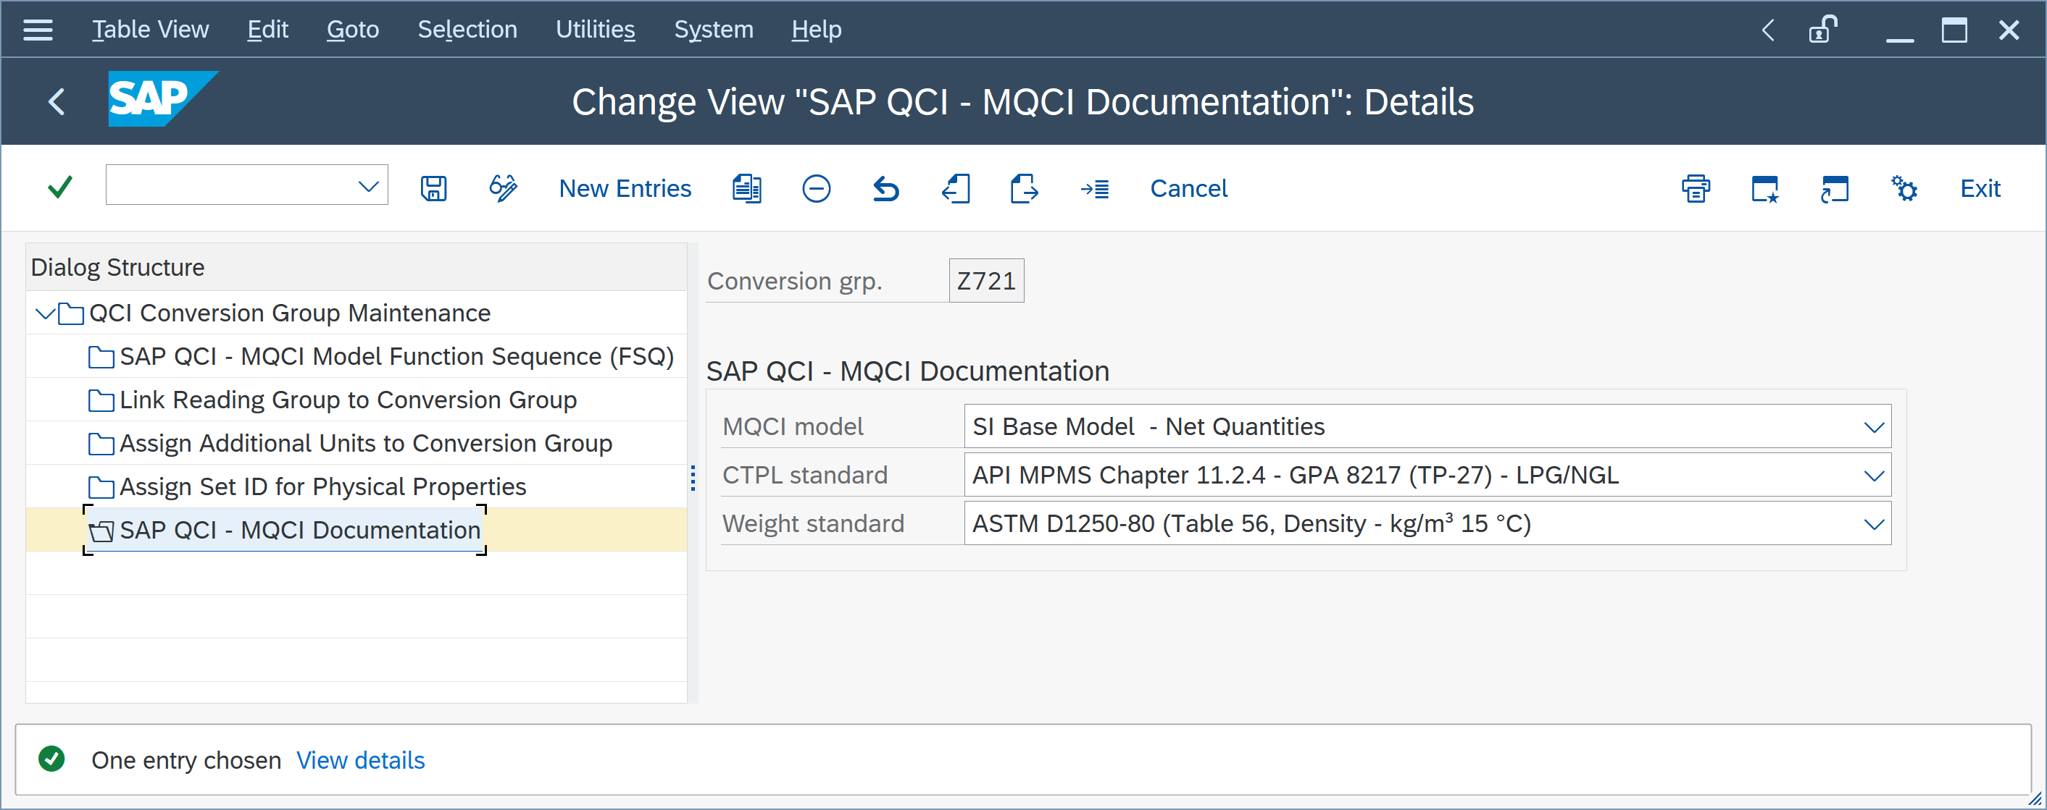
Provide your screen print:

Part 3 - Reading Group Configuration
- Via the PMC, navigate to menu path: Goto Reading Groups:
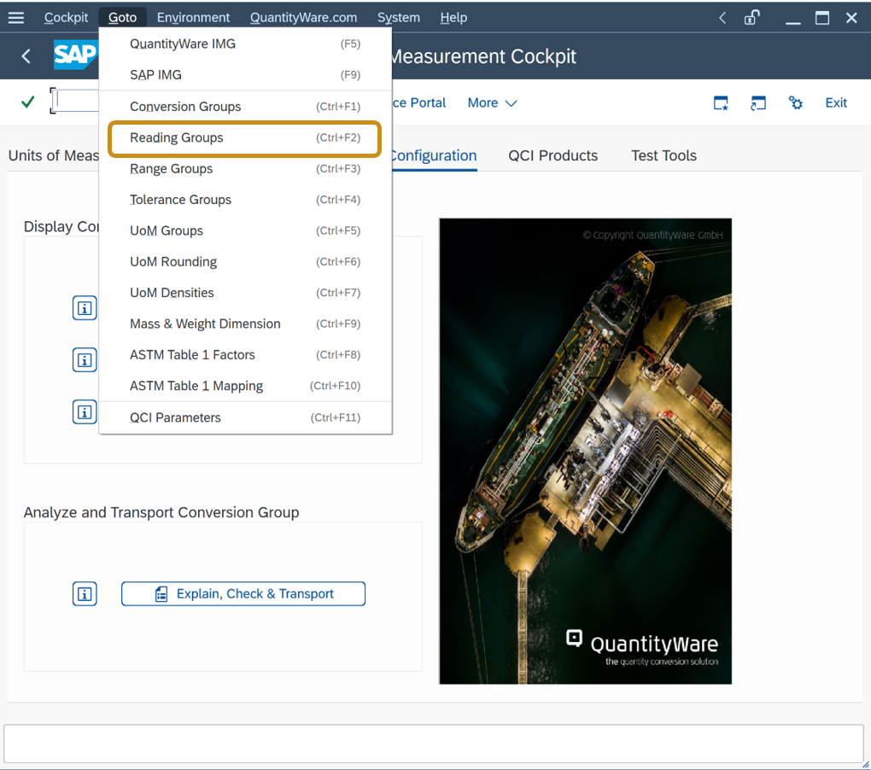
- Provide a screen print of the affected reading group – Overview
Example:
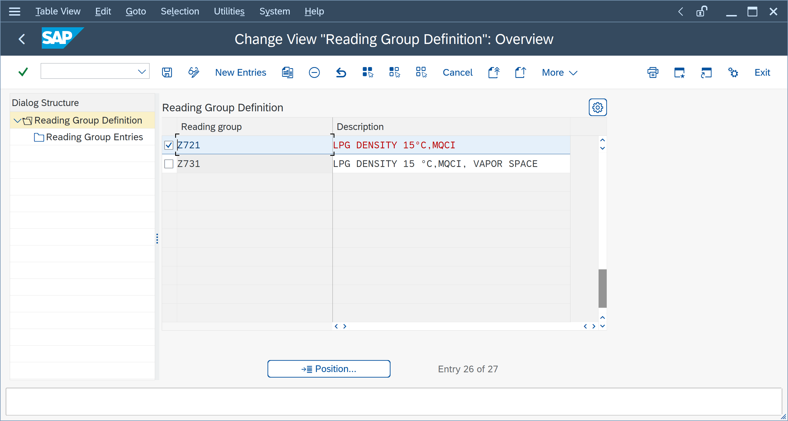

Provide your screen print:

- Provide a screen print of all reading group entries
Example:
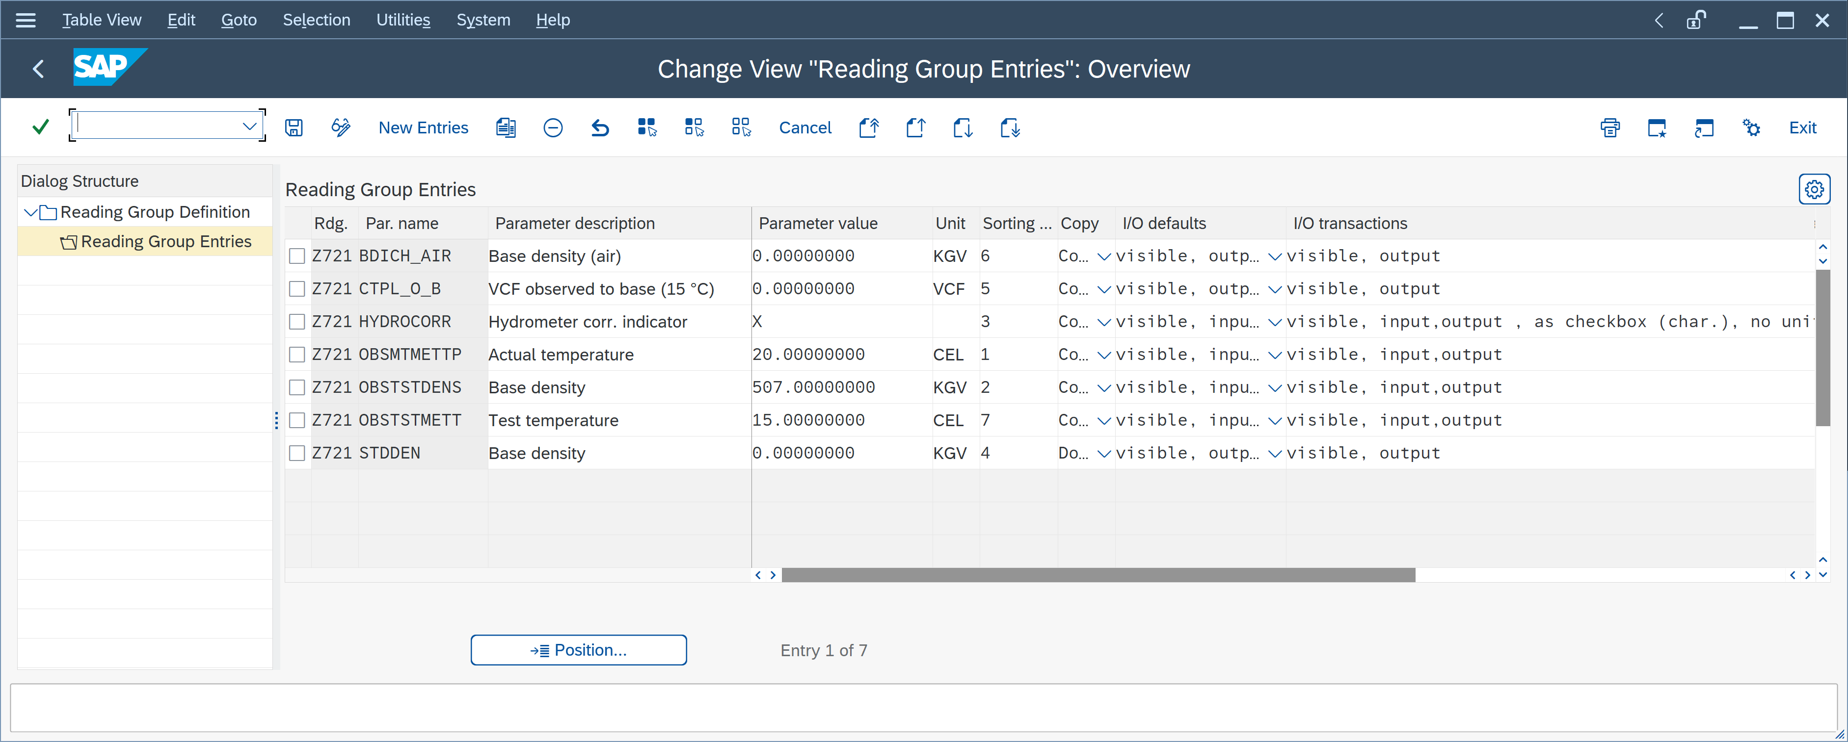
Provide your screen print:

Summary
Provide all screen prints as described above. If your conversion group configuration contains customer specific Z*** ABAP functions, include that code as well.
If screen prints are missing, QuantityWare support staff may send back your ticket requesting completion before an analysis can be started.
The example in this questionnaire covers common standard configuration settings.
However, since the conversion group configuration (e.g., for LNG, NGL/LPG and natural gas or dedicated rounding requirements) depends on many more configuration tables, QuantityWare support may ask you to provide additional screen prints before the analysis can start.

Legal Notices
© Copyright 2023 QuantityWare GmbH. All rights reserved.
SAP, R/3, mySAP, mySAP.com, xApps, xApp, SAP NetWeaver, and other SAP products and services mentioned herein as well as their respective logos are trademarks or registered trademarks of SAP AG in Germany and in several other countries all over the world. All other product and service names mentioned are the trademarks of their respective companies.
Microsoft, Windows, SQL-Server, Powerpoint and Outlook are registered trademarks of Microsoft Corporation.
These materials and the information therein are subject to change without notice. These materials are provided by the company QuantityWare GmbH for informational purposes only. There is no implied representation or warranty of any kind, and QuantityWare GmbH shall not be liable for errors or omissions with respect to the materials provided. The only warranties for the products and services of QuantityWare GmbH are those set forth in the express warranty statements accompanying such products and services, if any. No statement within this document should be construed as constituting an additional warranty.

